 

***Millington International***

***Youth Academy***



Millington International Youth Academy

4641 Shelby Road, Millington TN 38053

Phone: (901) 873-2660 Fax: (901) 873-2660

Email: imbinv@bigriver.net



**Childcare & Preschool**

**Application Packet**

**Serving children 6 weeks old through 12 years old**

**Included in packet:**

1. **Enrollment Information**
2. **Emergency Record**
3. **Person(s) authorized to pick up child/ Immunization Schedule**
4. **Medical Treatment Authorization**
5. **Health and Illness Policy**
6. **Preschool Program Information Sheet**
7. **Childcare/ Preschool Agreement**

**Please return this entire packet, along with the enrollment fee, to**

**reserve your child’s placement. Please do NOT remove any pages**

**from this packet.**

Millington International Youth Academy

4641 Shelby Road, Millington TN 38053

Phone: (901) 873-2660 Fax: (901) 873-2660

Email:imbinv@bigriver.net



Enrollment Information

Child’s Name Child’s Nickname

Birth Date

Address

(House Number and Street) (City, State, Zip Code)

Mailing Address (if different)

(House Number and Street) (City, State, Zip Code)

**Mother’s Name**

Mother’s Address (if different)

(House Number and Street) (City, State, Zip Code)

Mother’s Home Phone Mother’s Cell Phone

Mother’s Place of Employment

(Company Name) (Work Phone #)

Mother’s Work Address

(Number and Street) (City, State, Zip Code)

**Father’s Name**

Father’s Address (if different)

(House Number and Street) (City, State, Zip Code)

Father’s Home Phone Father’s Cell Phone

Millington International Youth Academy

4641 Shelby Road, Millington TN 38053

Phone: (901) 873-2660 Fax: (901) 873-2660

Email:imbniv@bigriver.net



Father’s Place of Employment

(Company Name) (Work Phone #)

Father’s work Address

(Number and Street) (City, State, Zip Code)

Phone # where child’s Father can be reached while at our center

Date Enrolled Date Withdrawn

Our weekly rate is based on the hours that I agree and schedule to use for childcare/ preschool, not on the actual hours my child attends, if less. Payment is due whether or not my child attends during those hours.

I agree that Millington International Youth Academy Preschool ONLY follows the Shelby County school calendar. If Shelby County is closed, for any reason, Millington International Youth Academy Preschool will also be closed.

**Millington International Youth Academy: August through May**

Millington International Youth Academy observes the following days as PAID holidays (Both childcare and preschool will be closed):

**2013 2014**

1. Jan 1- New Year’s Day 1. Jan 1- New Year’s Day
2. May 27- Memorial Day 2. May 27-Memorial Day
3. July 4- Independence Day 3. July 4- Independence Day
4. Nov 28- Thanksgiving 4. Nov 28- Thanksgiving
5. Dec 24/ 25- Christmas Day 5. Dec 24/25- Christmas Day

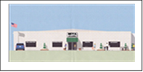

Millington International Youth Academy

4641 Shelby Road, Millington TN 38053

Phone: (901) 873-2660 Fax: (901) 873-2660

Email: imbinv@bigriver.net

I agree that the rates stated herein are payable I full for the calendar year **Excluding**  Millington International Youth Academy’s vacation. **In all other situations, I am obligated to as specified in this agreement.**

**Damages:**

Both Millington International Youth Academy and I will make every effort to teach my child to use materials carefully and to avoid damaging property that belongs to others. However, in the case of damage over $10. 00, I agree to cover the cost of replacement and repair.

**I Agree To:**

1. Pay the stated rates, fees, and late fees as specified in the contract.

2. Call, if my child will not be attending childcare/ preschool.

3. Give TWO weeks-notice, if I plan to stop bringing my child to childcare/ preschool.

4. Provide two changes of clothing, appropriate for the weather, to be left in my child’s cubby.

5. Provide disposable diapers, wipes, bottles, baby food, and formula (if applicable)

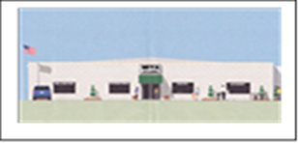

Millington International Youth Academy

4641 Shelby Road, Millington TN 38053

Phone: (901) 873-2660 Fax: (901) 873-2660

Email: imbinv@bigriver.net

6. Provide alternate care in the case of emergency or instances where Millington International Youth Academy is unable to care for my child without advance notice.

7. Not bring any of my child’s toys to childcare (Security blanket such as or stuffed animal for nap can be brought as needed). MIYA will not be held responsible for damage, laundering, or lost items.

8. Arrive with myself and my child dressed in appropriate clothing daily.

9. Feed my child at home, if I have missed the scheduled mealtime (see #8 under Operating Policies).

11. If I want my child to eat anything other than what id provided by Millington International Youth Academy, I must provide it for my child.

**Operating Policies:**

1. Both Millington International Youth Academy and I will give each other TWO weeks-notice about vacations, termination, reduction, or any other changes.
2. Meals and snacks will be provided by Millington International Youth Academy. If my child is not on regular food, I will provide formula, baby food, or any other appropriate nutrition. Food must be unopened and labeled.
3. My child must be at least six weeks old in order to attend.
4. A $25.00 charge will be assessed to my account for any bad checks. All future payments will be made in cash.
5. If my child is sick while in Millington International Youth Academy’s care, I will be called and must pick up my child immediately.



Millington International Youth Academy

4641 Shelby Road, Millington TN 38053

Phone: (901) 873-2660 Fax: (901) 873-2660

Email: imbinv@bigriver.net

1. If I want Millington International Youth Academy to give my child medication, I must provide a written note authorizing such. The note must include how much and how often to give the medication. The medication must contain the original prescription, be unexpired, and labeled with my child’s name.
2. Only those people listed on the “Authorized to pick up my child list” are allowed to pick up my child.
3. Meals will be served at these approximate times: Breakfast 7:00-8:00, Lunch 11:30-12:30, PM Snack 3:00-4:00.
4. I understand that foreign language classes are free. The classes will be filled on first come basis until all slots are filled. Spanish is offered to 3and 4 year olds only. If I do not wish for my child to participate in the class, I will request non-participation in writing.

Example:

I, , request that my child , not participate in the foreign language classes.

Signed

1. I agree to share with Director any pertinent information that may adversely affect my child’s mental or physical health, I understand that this information is confidential, but may need to be shared with my child’s teacher.

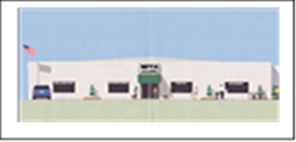

Millington International Youth Academy

4641 Shelby Road, Millington TN 38053

Phone: (901) 873-2660 Fax: (901) 873-2660

Email:imbinv@bigriver.net

Signature (Mother) Date Owner/ Director Date

Printed Name

Signature (Father) Date

Printed Name

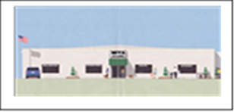

Millington International Youth Academy

4641 Shelby Road, Millington TN 38053

Phone: (901) 873-2660 Fax: (901) 873-2660

Email: imbinv@bigriver.net

**Emergency Record**

Child’s Name:

Person to be contacted in the event of an emergency when child’s parents cannot be reached:

(Name) (House Number and Street) (City, State, Zip Code)

(Home Phone) (Work Phone)

Does your child have any allergies? If yes, please describe.

Does your child have any special needs? If yes, please describe.

Does your child have any other health conditions? If yes, please describe.

Is there any other information of which I should be aware?

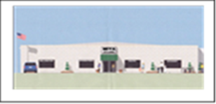

Millington International Youth Academy

4641 Shelby Road, Millington TN 38053

Phone: (901) 873-2660 Fax: (901) 873-2660

Email: imbinv@bigriver.net

Child’s Physician:

(Name) (Phone)

(Doctor’s Office Name) (Number and Street) (City, State, Zip Code)

Child’s Dentist:

(Name) (Phone)

(Dentist Office Name) (Number and Street) (City, State, Zip Code)

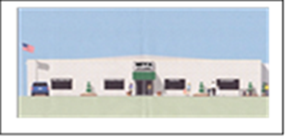

Millington International Youth Academy

4641 Shelby Road, Millington TN 38053

Phone: (901) 873-2660 Fax: (901) 873-2660

Email: imbinv@bigriver.net

**Persons Authorized To Pick Up My Child**

Child’s Name:

My Password is .

**Only the people listed below (with photo ID) will be able to pick up your child.**

Name Phone #

Name Phone #

Name Phone #

Name Phone #

Name Phone #

Name Phone #

Name Phone #

Name Phone #

Name Phone #

Parent’s Signature Date

MIYA Date

**Immunization Schedule for Normal Infants/ Children**

Please provide us with an updated copy of your child’s shot records each time your child receives an immunization.

The Immunization Practices Advisory Committee (ACIP) recommends the following childhood immunization schedule.

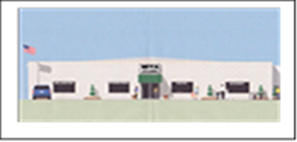

Millington International Youth Academy

4641 Shelby Road, Millington TN 38053

Phone: (901) 873-2660 Fax: (901) 873-2660

Email: imbinv@bigriver.net

**Immunization Schedule for Normal Infants/ Children**

Please provide us with an updated copy of your child’s shot records each time your child receives an immunization (only the state approved form is acceptable).

The Immunization Practices Advisory Committee (ACIP) recommends the following childhood immunization schedule.



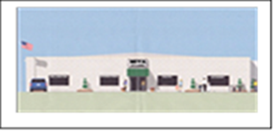

Millington International Youth Academy

4641 Shelby Road, Millington TN 38053

Phone: (901) 873-2660 Fax: (901) 873-2660

Email: imbinv@bigriver.net

**AUTHORIZATION AND CONSENT FOR MEDICAL TREATMENT**

I (We) and

(Name) (Name)

Of , do hereby state that I am (We are) the

(City) (State)

natural Parent(s), (legal guardian) having legal custody of

(Child’s Name)

Born who resides with me (us) at

(Date) (Address)

I (We) consent to any x-ray, examination, anesthetic, medical or surgical diagnosis or treatment and hospital care, to be rendered to the minor under the general or special supervision and on the advice of any physician or surgeon licensed to practice in the state of Tennessee when the need for such treatment is immediate, and when the efforts to contact me (us) are unsuccessful.

Consent is valid for five years or until termination.

Dated this day of ,

(Day) (Month) (Year)

(Signature)

(Signature)

Millington International Youth Academy

4641 Shelby Road, Millington TN 38053

Phone: (901) 873-2660 Fax: (901) 873-2660

Email: imbinv@bigriver.net

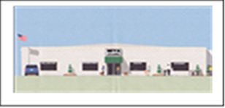

**HEALTH & ILLNESS POLICY**

**Emergency Phone Numbers:**

Fire/ Police Ambulance: (901) 872-3333

Tennessee Poison Control Center: 1(800) 288-9999

**Medication: All prescription medication must be prescribed by a doctor specifically for your child and must be accompanied by a written schedule of when and how much to give your child.** Only Director or designated staff will dispense medication when the “Authorization to Administer Prescription and Non-Prescription Medication” form is completed by parent or guardian.

**Antibiotics:** A child with a contagious condition for which antibiotics have been prescribed may NOT attend daycare if he/she shows signs of illnesses as outlined below. This policy is for the benefit and protection of all children and staff.

**Diarrhea**: A child with diarrhea must stay (or go) home until the diarrhea has stopped and normal bowel movements have resumed.

**Fever**: When a child has a fever above 100 degrees orally or above 101 degrees rectally, he/she must stay home until the child has been fever-free for 24 hours. If a fever develops during the day, we will call you and you MUST pick up your child as soon as possible.

**Head** Lice: a child with head lice must stay home until specific treatment is completed and lice and nits in hair and clothing are absent.

**Impetigo** and **Conjunctivitis**: These are very contagious conditions and must be treated with antibiotics before the child may attend. If your child has red, runny eyes or scabby sores, I will notify you. Your child MUST be taken out of daycare until he/she has been seen by a doctor and been on medication for AT LEAST 48 hours.

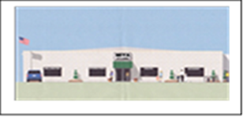

Millington International Youth Academy

4641 Shelby Road, Millington TN 38053

Phone: (901) 873-2660 Fax: (901) 873-2660

Email: imbinv@bigriver.net

Runny Nose: Generally, a clear discharge is okay, and a thick yellow-greenish discharge is a sign of a more serious infection. This is more dangerous for younger, rather than older children, and we will use our discretion about asking you to keep your child at home.

Strep Throat: A child with strep throat must not attend day care until he/she has been on antibiotics for 24 hours and is symptom-free and feeling well.

Vomiting: A vomiting child MUST go home if he/she becomes ill at daycare. He/ She cannot attend daycare until vomiting has stopped for at least 24 hours.

Shot Records: You need to provide a photocopy of your child’s shot records for our records. As your child has additional shots, we also need our photocopy updated. The state requires that all children enrolled in daycare have current immunizations.

**Before returning to care: If you take your child to a doctor because of an illness, you need a note from the doctor explaining the illness, treatment, and when your child can return to daycare. It is very important to follow these policy rules. They reflect a common respect and responsibility to protect the children from illnesses.**

Please sign below stating that you have read and understand Millington International Youth Academy’s Health & Illness Policy.

Parent’s Signature: Date:

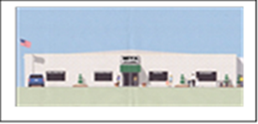

Millington International Youth Academy

4641 Shelby Road, Millington TN 38053

Phone: (901) 873-2660 Fax: (901) 873-2660

Email:imbinv@bigriver.net

**SAMPLE OF:** Authorization to Administer Prescription & Non-Prescription Medication

I authorize Millington International Youth Academy to administer the following medication (if applicable)

Child’s Name

Name of medication

Amount to be given

Times to be given (parent MUST give first dose)

Duration of date authorization ends

Special instructions for administering



Millington International Youth Academy

4641 Shelby Road, Millington TN 38053

Phone: (901) 873-2660 Fax: (901) 873-2660

Email:imbinv@bigriver.net

**2013-2014**

**Preschool Program**

**HOURS:**

**Preschool only:** 9:00am-11:30am

Half-day preschool is offered 2,3, 4 and 5 days a week. (for fees see schedule)

**All Day Childcare( including Preschool):** 6am-6pm M-F

Fee: $125.00

**REGISTRATION FEE: $30.00 (Renewed Annually)**

MIYA Preschool follows the Shelby County school calendar.

The following Preschool supplies are to be provided by the parent. Please write your child’s name on his/her supplies. Wal-mart and K-mart stock all supplies.

1. Crayons- Crayola Brand
2. Water Colors- Crayola Brand
3. Markers- Crayola Brand
4. Safety Scissors- Crayola or Fiskar Brand
5. Colored Pencils- Crayola Brand
6. Glue- Elmer’s School Glue
7. Paint Shirt- Adult T-shirt works great

We look forward to having both your child and you involved in our program. If you ever have any questions, please do not hesitate to ask.



Millington International Youth Academy

4641 Shelby Road, Millington TN 38053

Phone: (901) 873-2660 Fax: (901) 873-2660

Email: imbinv@bigriver.net

**CHILDCARE/ PRESCHOOL AGREEMENT**

**Hours and Fees:**

I am contracting with Millington International Youth Academy for childcare/preschool for

, Date of Birth

(Child’s Name)

Terms of our agreement are as follows:

This contract is valid starting the week of

**Registration Fee:** $30.00(annual fee)

**August through May (School Year):**

**Weekly Rate of $**

**June and July (Summer Program):**

**Weekly Rate of $ for the days and hours of: (6am-6pm_10 hours only)**

**Late Fee (after 5pm) $15.00/ 5min $1.00/ min after:**

**Fees are payable in advance. They are due no later than drop off time at the beginning of each week. If payment is not made on the first day of the week, a $10.00 late fee will be charged to my account. An additional $10.00 per week will accrue until bill in full.**



Millington International Youth Academy

4641 Shelby Road, Millington TN 38053

Phone: (901) 873-2660 Fax: (901) 873-2660

Email:imbinv@bigriver.net

**Millington International Youth Academy Staff**

Director

Cell Number

(Call or Text)

**My Child’s Teacher:**

Teacher

Assistant

**Foreign Language:**

Teacher Norma Brown

**Daycare Administrator:**

Name  Irene Beach

Cell Number (901) 487-7747

Email [imvinv@bigriver.net](mailto:imvinv@bigriver.net)

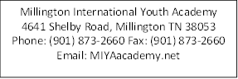

Car Seat Usage:

MIYA will have a limited amount of car seats for emergency purposes.

All Children must be transported in a car seat or booster seat.

In case of emergencies, there will be a $20.00 deposit for using a car seat.

The deposit will be returned when the car seat is returned. The car seat MUST be clean when it is returned.